Total Knee Replacement. Experienced surgeon with his team apply new methods in Apollonion
Dr Stelios Hadjichristofis, after long absence abroad and excelling professionally in academic and private hospitals of Johannesburg in South Africa, now working in Cyprus and offer his services from the Apollonion private hospital, in Nicosia, along with an experienced team.
Dr Stelios Hadjichristofis [FCS (SA) Orth./MMed (WITS) Orth.] has a long experience in Total knee Replacement (TKR) with expertise and extensive experience in robotic surgery since 2004 up to 2009. He is also fully trained and expert in Custom made knee arthroplasty--VISIONNAIRE [personalized arthroplasty of the knee). At the same time, he and his team are using all new techniques for Fast Track surgery on knee and also MIS (Minimally Invasive Surgery).
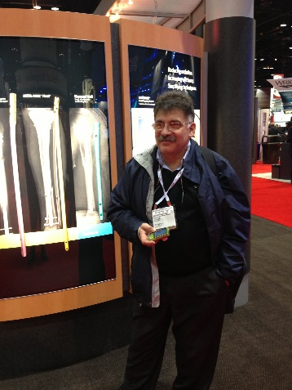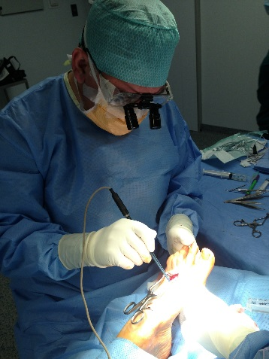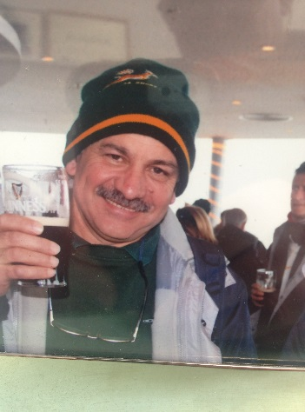
Dr Stelios Hadjichristofis FCS(SA)Orth. / MMed(WITS)Orth.
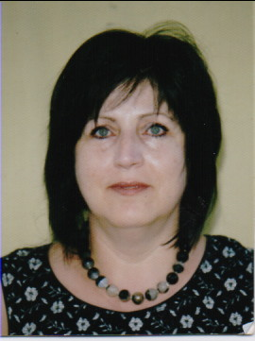
Dr Nedi Zannettou Specialist Rheumatologist ; Specialist Physician Lecturer – University of Witwatersrand Johannesburg

The radiology department of Apollonion hospital has clearance and full permission from Smith Nephew in Switzerland for authorized x-rays and MRI for ordering the custom made TKR - VISIONNAIRE. Those who wish to have this technique with adapting to the cost. The knees we are using, have got for the first time clearance of sustainability for 30 years by the American FDA. [Smith & Nephew Receives FDA 510k Clearance for a 30-year Knee. New wear simulator data shows Smith & Nephew's exclusive VERILAST™ technology reduces leading cause of knee implant failure by 81-percent over 30-year span. Apr 22, 2010]. The high level of technique of the surgeon is of the greatest importance.
For the selection and comprehensive preparation of the patient to Fast Track surgery, in the team participates, Doctor Zannettoy Nedi, specialist physician and Specialist rheumatologist specialists in South Africa. Preparation and evaluation of the patient is equally important and the cooperation of specialities in this area brings the best results possible for your safe and speedy recovery - Fast Track surgery.
In the surgical team also participates the Orthopaedic surgeon Dr. Antoniou Konstantinos, with extensive experience in Thessaloniki and Cyprus
To achieve these excellent results is of paramount importance the participation in the team of specialist anaesthetists and cardiologists with full knowledge and adherence to international protocols for safe and speedy recovery of our patients.
The Representatives of the company for implants fully trained and worked overseas, add to the high quality service from our team.
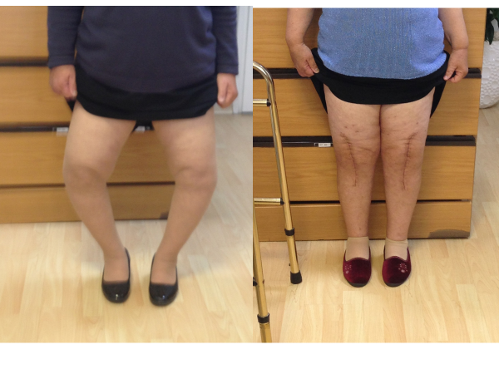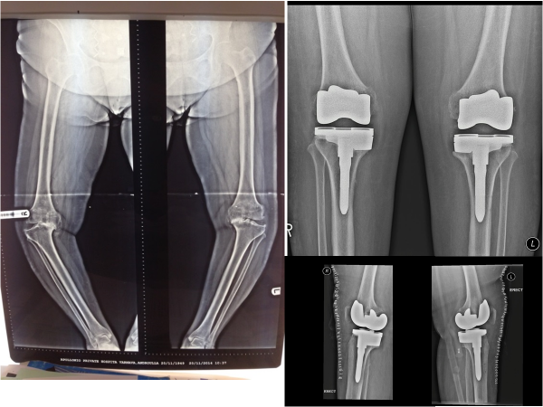
Extremely technically difficult operation. Both knees were done at the same time.

For details of the technical and other details of surgical procedures see articles and booklets written by Dr. Hatjichristofis: ArthroplastY hip and Knee – Myths and Realities / Total Knee ArthroplastY / Total Hip Replacement / Knee Arthroplasty schedule - Timeline / Visionaire. You can also contact us directly.

=============================================================================================

Mr Stelios Hadjichristofis FCS(SA)Orth. / MMed(WITS)Orth.

ORTHOPAEDIC SURGEON – Trauma, Sport Trauma, Arthroplasty, Arthroscopy,Hand & Foot surgery

Fellow of the College of Medicine of South Africa - FCS(SA)Orth.

Master of Medicine in Orthopaedics – University of Witwatersrand - MMed(WITS)Orth.

Member of the South African Orthopaedic Association

Affiliate Member of the American Academy of Orthopaedic Surgeons

Member of ESSKA (European Society of Sports Traumatology Knee surgery and Arthroscopy)

Member of ISAKOS(International Society of Arthroscopy, Knee Surgery and Orthopaedic sports Medicine)

Holder of the Greek Orthopaedic Exams – Athens

Senior Lecturer at the University of Witwatersrand Medical school - Johannesburg
e-mail: hadjichristofis.stelios@cytanet.com.cy
cell: 00357 99722555 web: http://orthodoc.aaos.org/Hadjichristofis/
Phone: 22469089 / 092 www.bonejointcyprus.com

